Numerical Relativity

Exercise-1

Demetry Alfalahat

ID: 922365

Exercise 1-1

Note for the plots: Time is the time step (The function running period). is the Courant factor. j is the resolution (number of points in the domain [] as )

Advection Equation 🡪

Solving the advection equation using 4 schemes (FTCS, Lax-Friedrich, Lax-Wendroff, and Leapfrog) on Jupyter Lab using Python.

Initial data:

1- FTCS scheme:

Theoretically, this scheme is unstable because it does not satisfy the CFL “a derivation was done in the class which shows how CFL condition is not satisfied with all the parameters that affect the stability”. Using numerical solution, the theoretical result was confirmed as Figure 1 shows: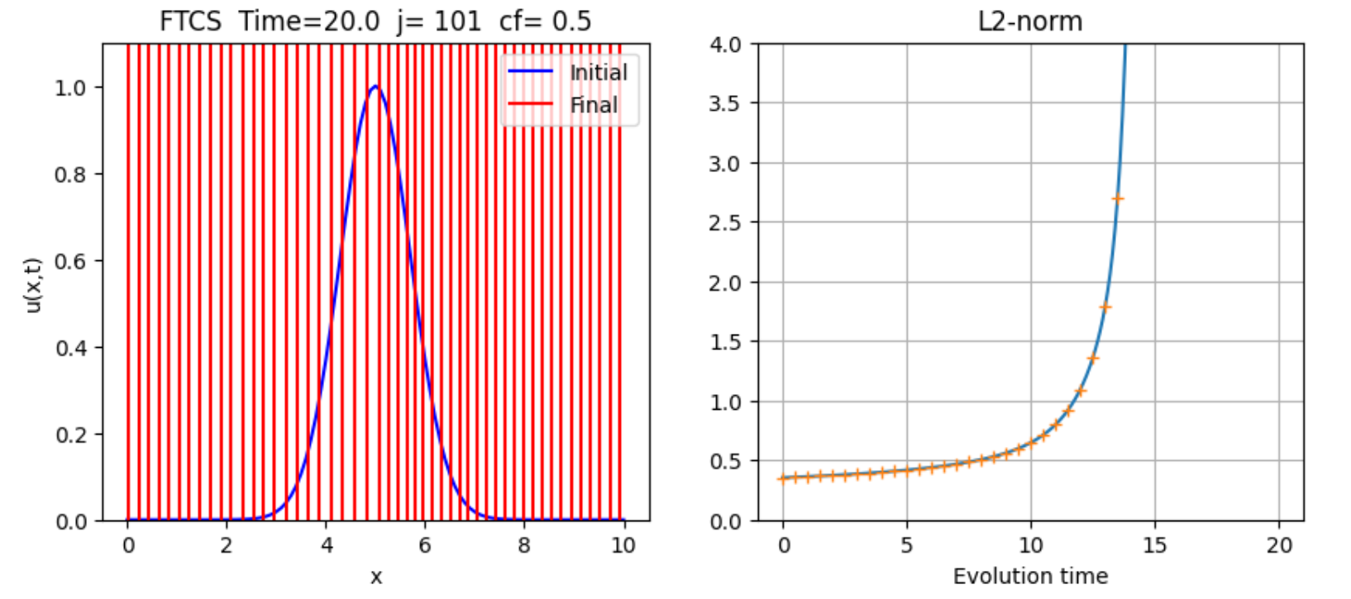

Figure 1: The plot on the left shows the initial data in blue while the data after solving the function with the FTCS scheme are in red. On the right, the plot shows the scheme state where it diverges because the function is unstable. The + sign in the plot on the right are saved values to be compared next after changing the cf, j and the time period.

Here are the snapshots of the function evolution through time for the same initial conditions described in Figure 1:

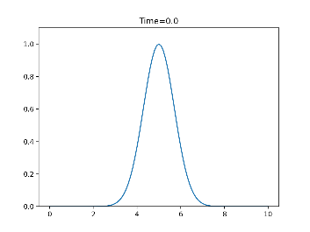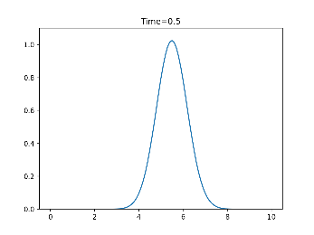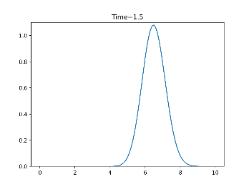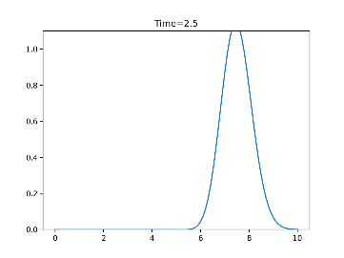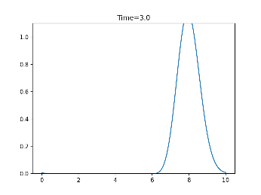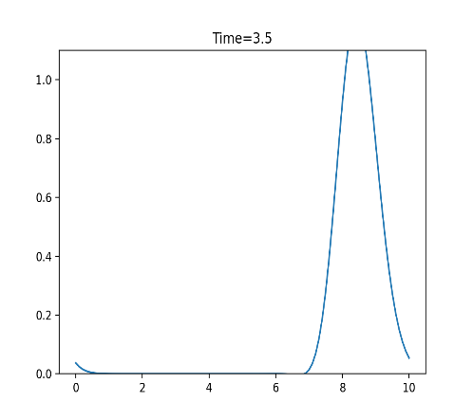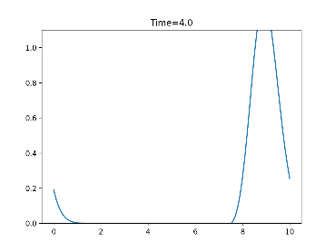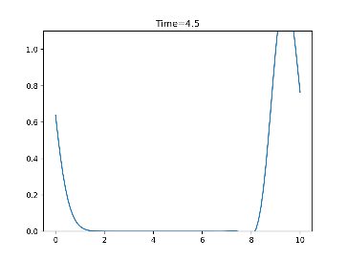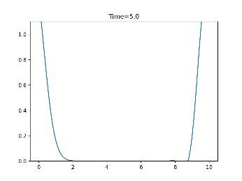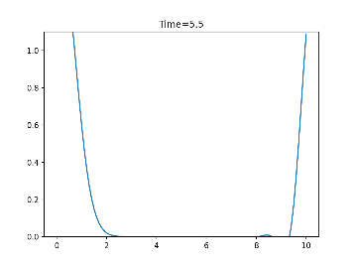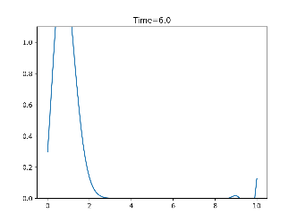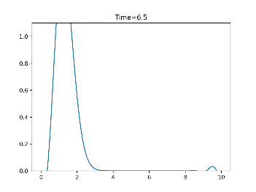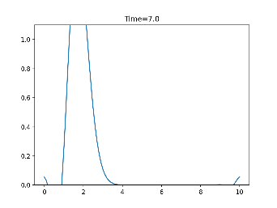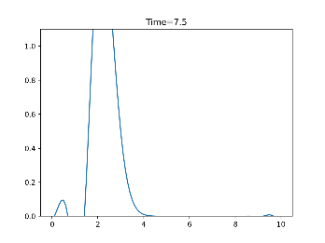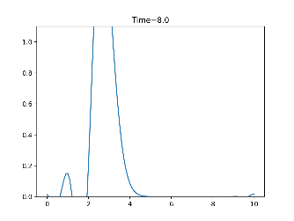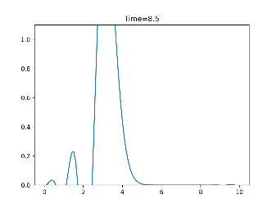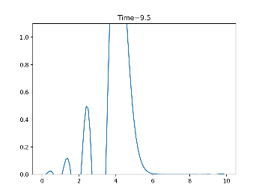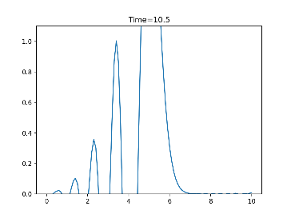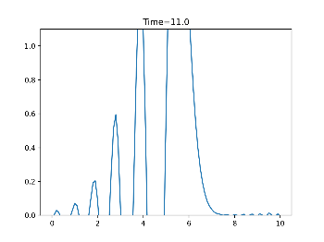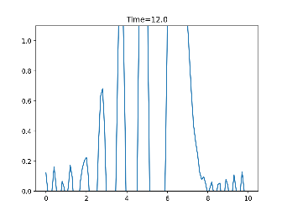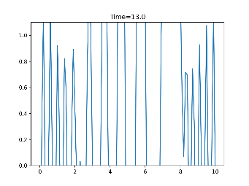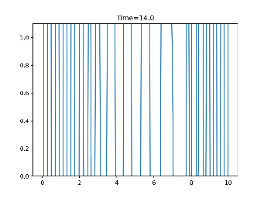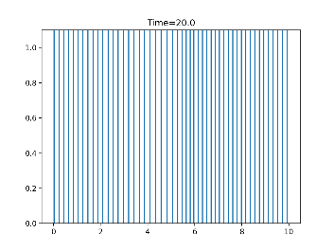

The FTCS scheme increases the maximum value of u(x,t) as we increase the evolution time and the Courant factor (Figure 2). While reducing the Courant factor, it would prevent the function from growing for a longer time (see Figure 3 and compare the norms in Figures 1,2 & 3).

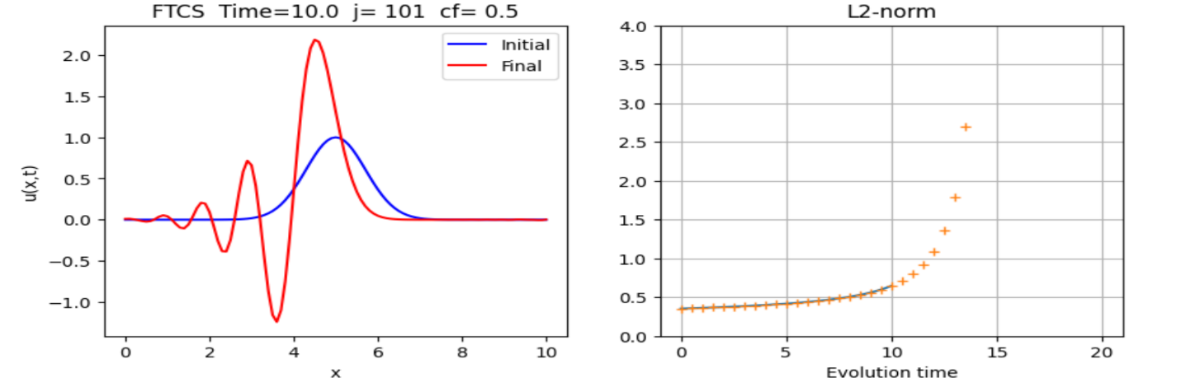

Figure 2: The plot starts perturbation but it stops due to the small-time interval without diverging.

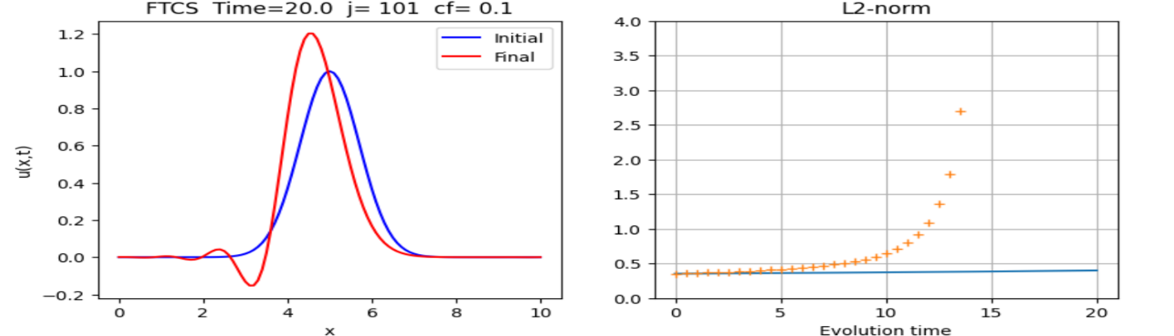

Figure : The plot now is more stable due to reducing the cf. On the right, the norm grows slowly.

Increasing the resolution (j) would reduce the perturbations as shown in Figure 4. Although, if we increased the cf or Time for a certain value, the perturbations will be the same as in Figure 1.

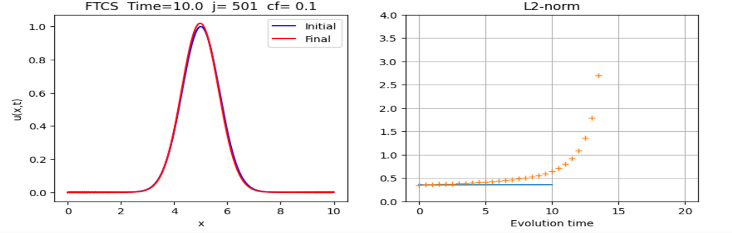

Figure : Perturbations vanished after increasing the resolution(j) and in a relatively short period.

2- Lax-Fredrich scheme:

Unlike the FTCS method, Lax-Fredrich’s scheme is stable both theoretically and confirmed by numerical simulations and converges as the L2-norm shows in Figure 5:

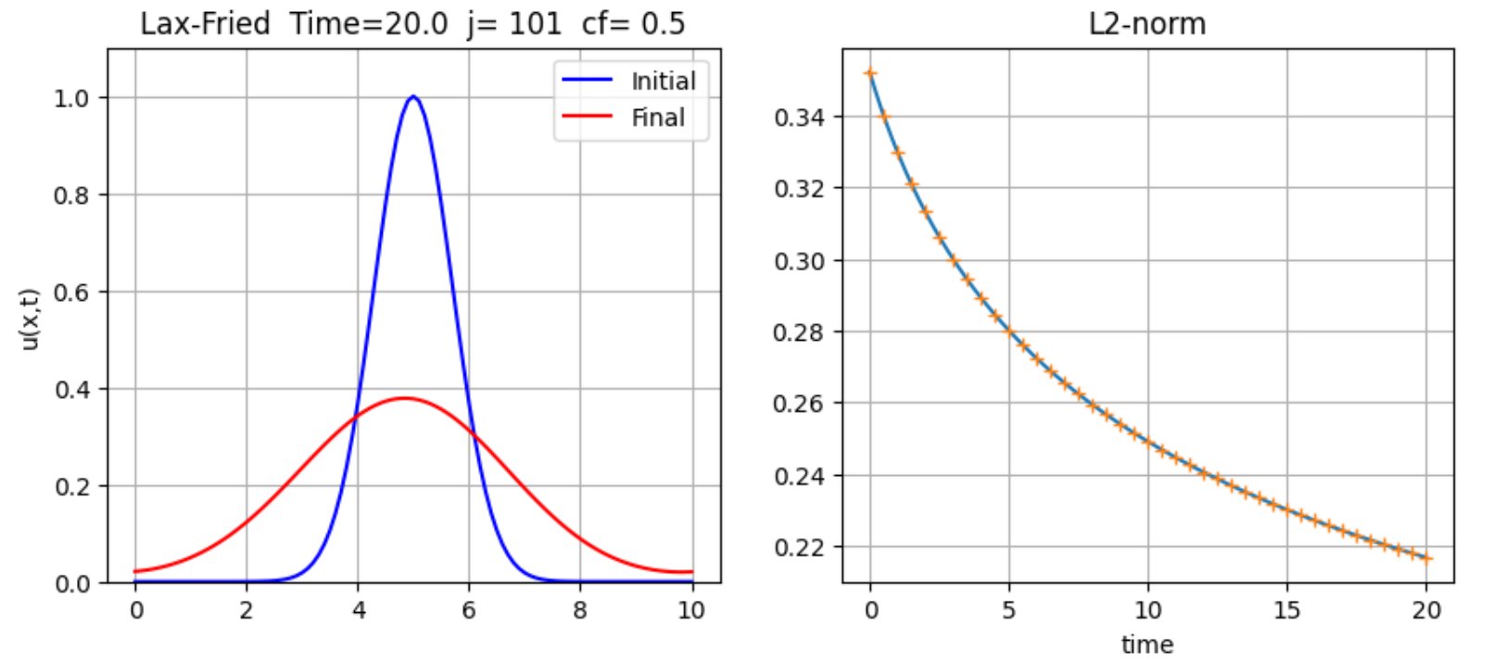

Figure 5: Lax-Friedrich’s initial data in blue and the Final data after the numerical computation in red.

The function dissipates through time (u becomes less) as we can see in these snapshots. The function starts to move from left to right as you go with the pictures from top left.

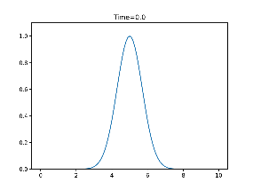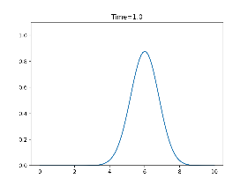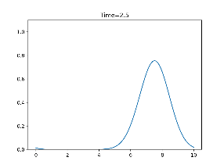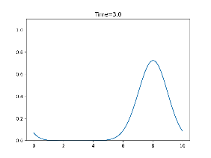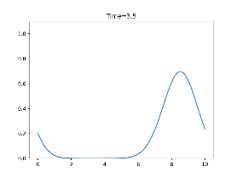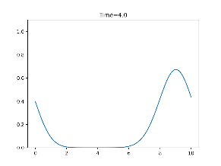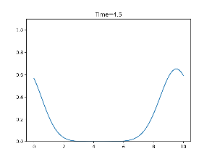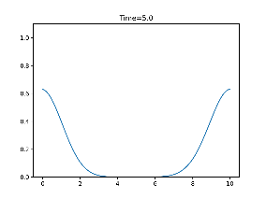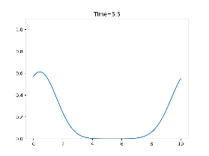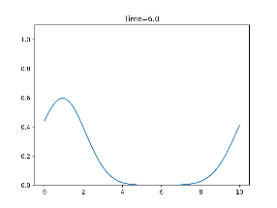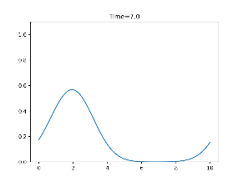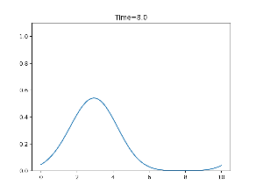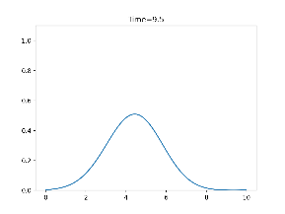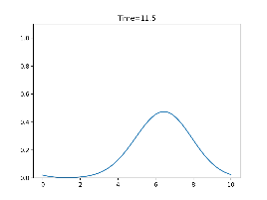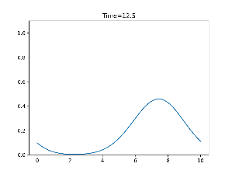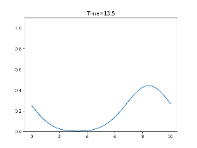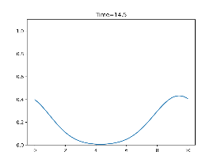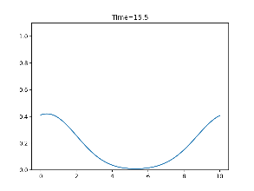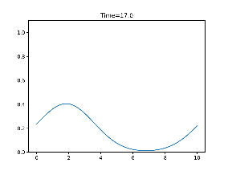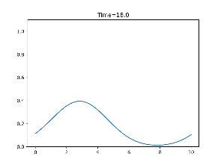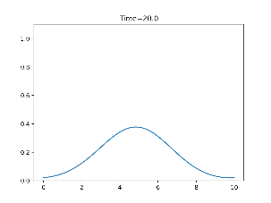

Figure 6: Lax-Friedrichs numerical simulation snapshots.

As we increase the resolution or the Courant factor, the final data becomes more aligned with the initial one and the function more stable as L2-norm represents in Figures 7&8:

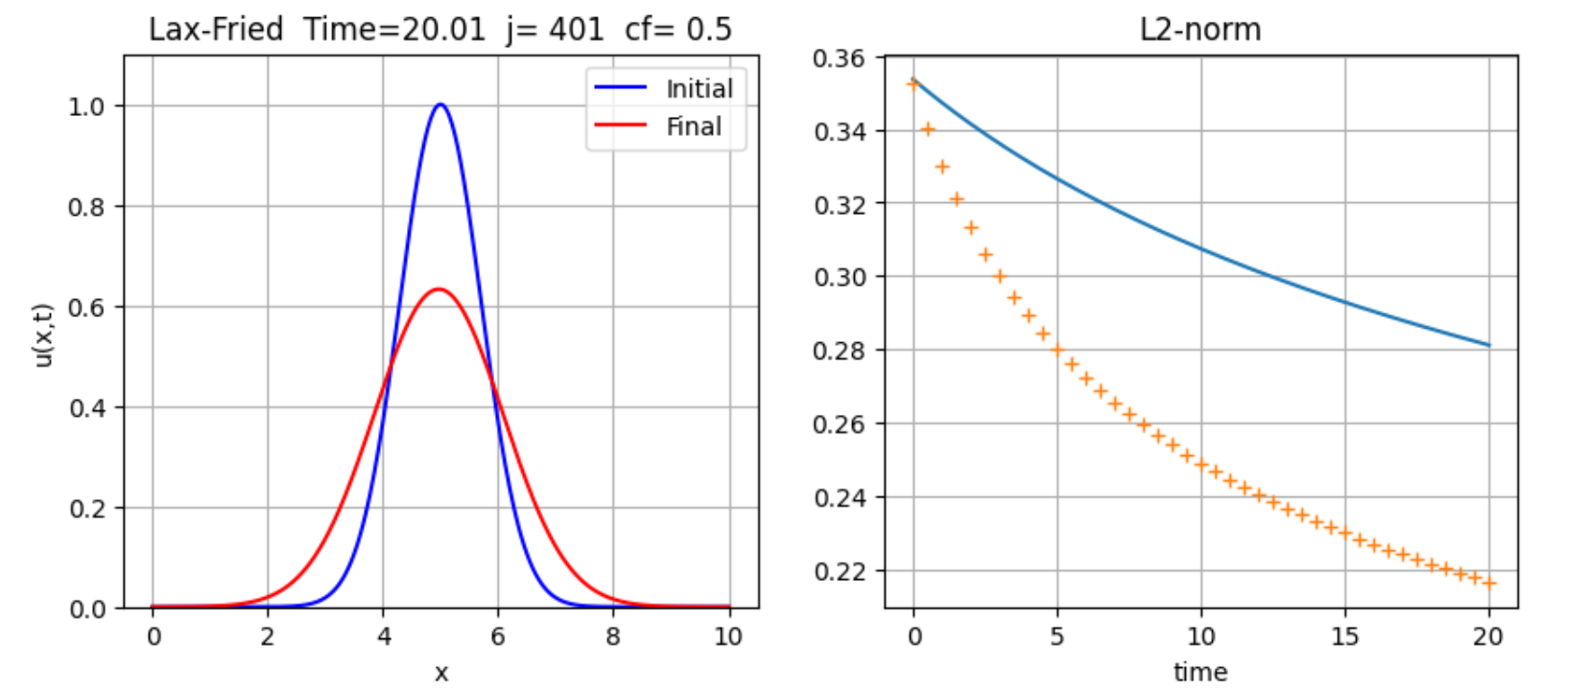

Figure 7: Increasing j gives the final data in red higher value (compare the highest value in figures 5,6 & 7).

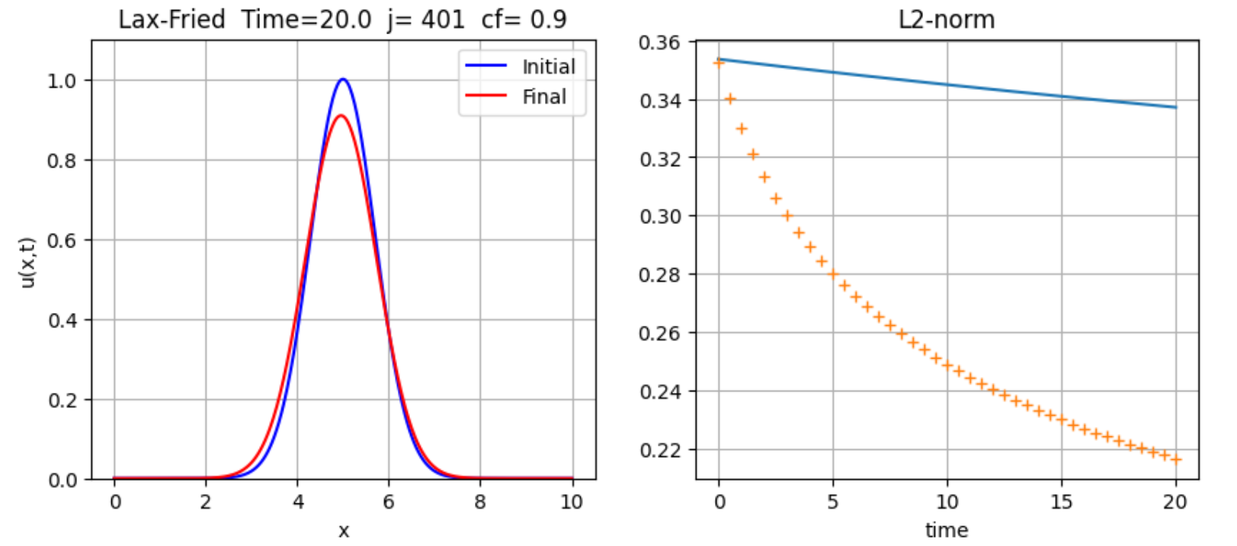

Figure 8: The function becomes stable more and more as we increase the cf or j (compare j and cf values with figure 6.

No need to show another numerical simulation with increasing time as it is obvious that the function becomes more stable with time (also, time is proportional to the cf).

3- Leapfrog scheme:

The plot in Figure 9 shows the stability of the Leapfrog scheme compared to the FTCS and Lax-Friedrich schemes with the same values of j, cf and time (compare Figures 1,5 & 9):

The special property for leapfrog that it is very stable with small j as in figure 10. However, there is a notch around x = 3 that disappears by increasing j.

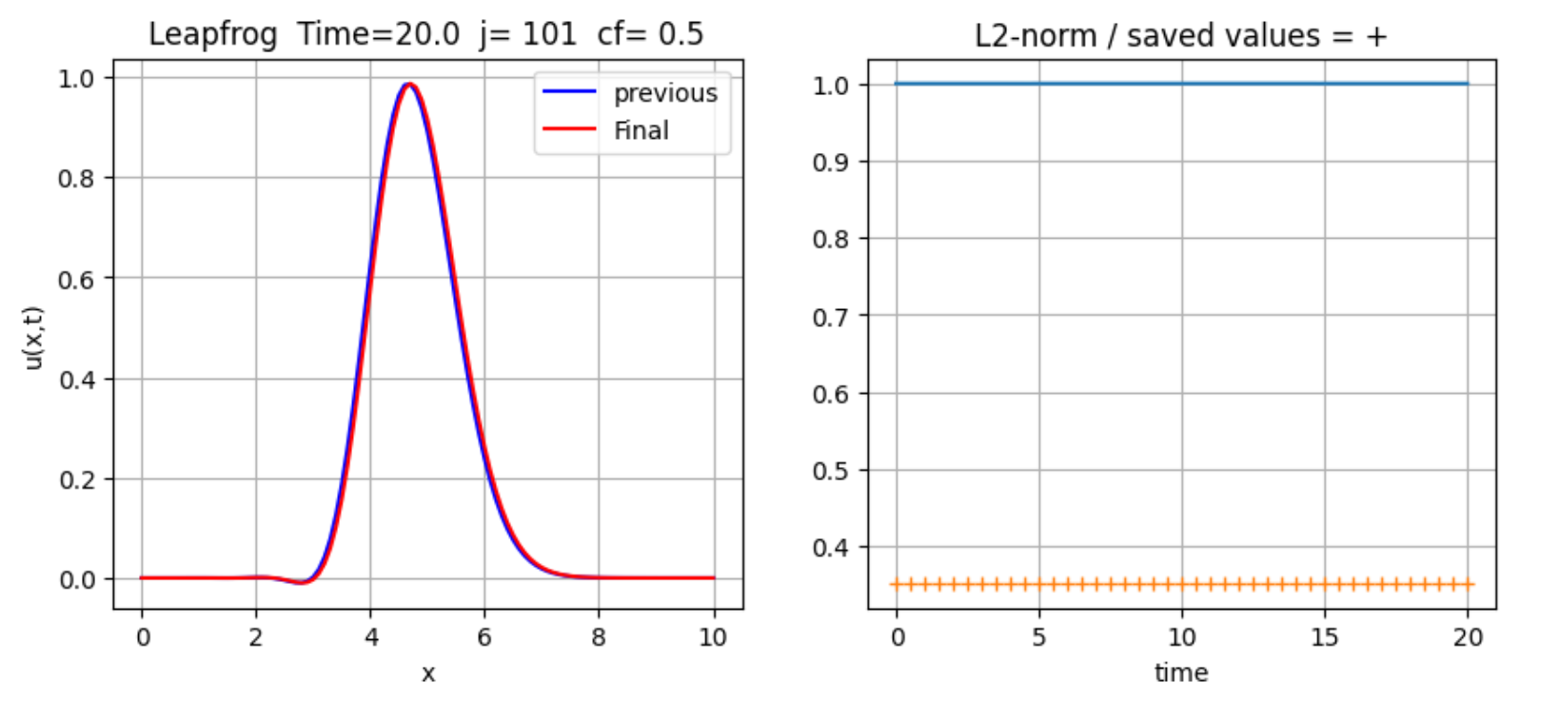

Figure 9: Leapfrog Plot, the final plot is perfectly aligned with the initial one (blue plot) except for the Notch around x = 3. For the L2-norm, we can’t see the values due to the difference between the values. Check Figure 11 for better clarification.

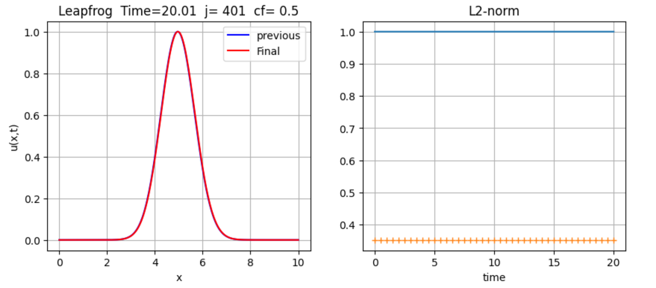

Figure 10: The notch disappeared and the plot is perfectly aligned with initial values (The blue plot behind the red one).

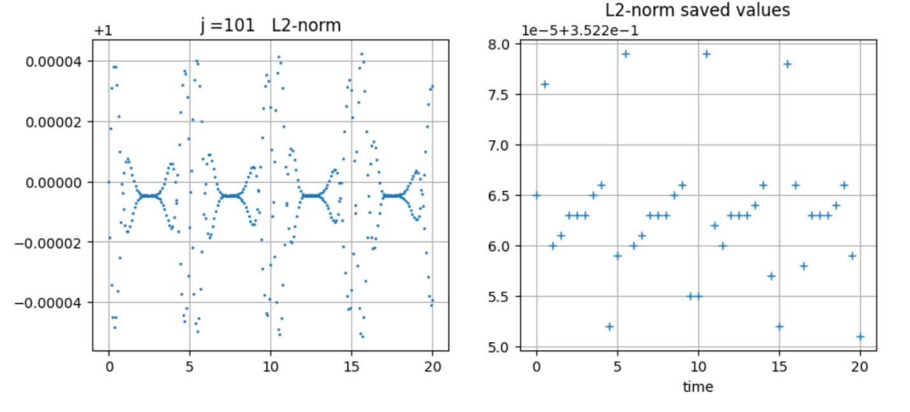

Figure 11: L2-norm for Figure 9. The left one is for the values regarding j = 101. Note the jumps around x = 5,10,15 and 20 between the 2 plots. The first value of L2-norm only is normalized in Figure 12

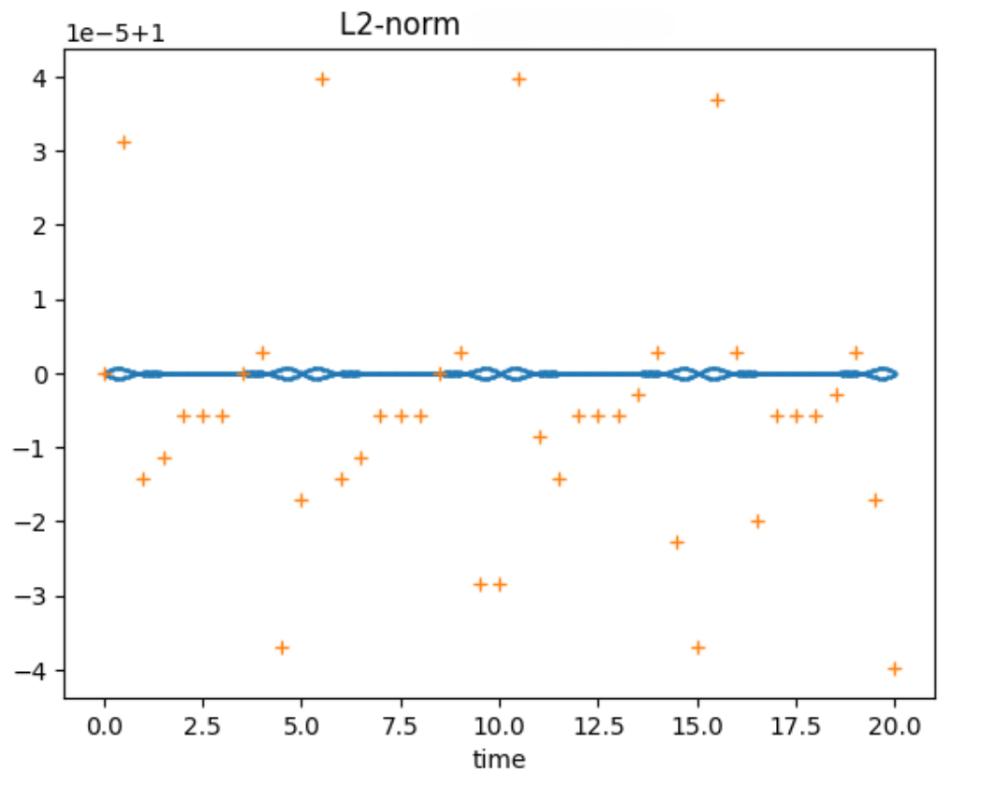

Figure 12: Only the first value of L2-norm which is at x = 0 is normalized.

One last Note for changing j or cf, it doesn’t make a noticeable change. Although, increasing j will give closer values for a very high-resolution simulation which is the one from the professor. Note the difference in the y-axis for these plots and the one in Figure 11, “”check the last plot j=4001 on the lab”:

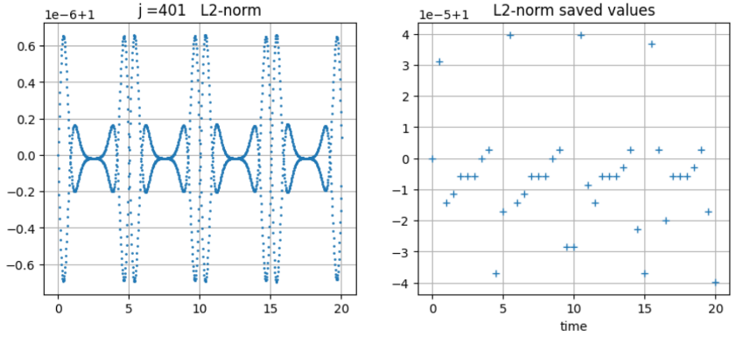

Here are the snapshots for Leapfrog simulation regarding the first case from figure 9:

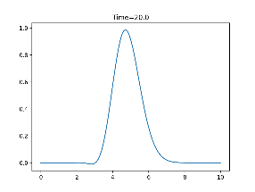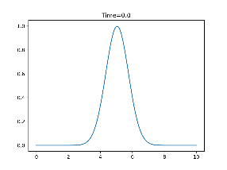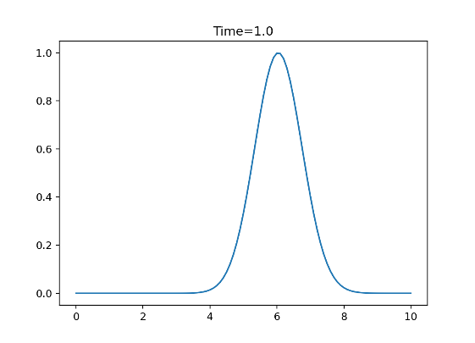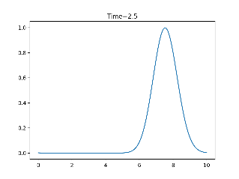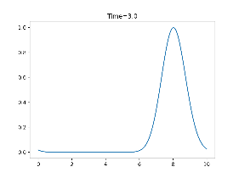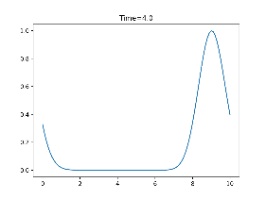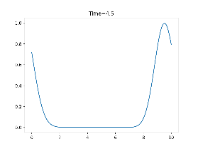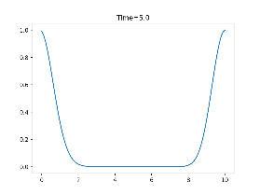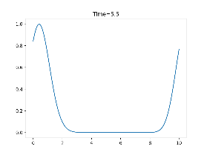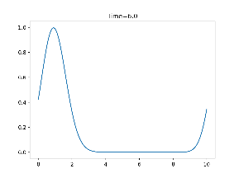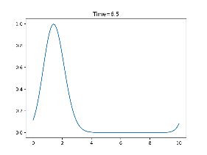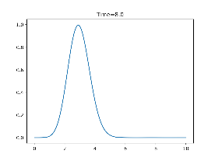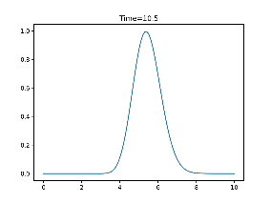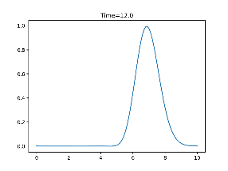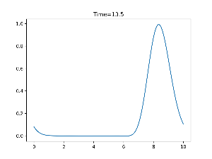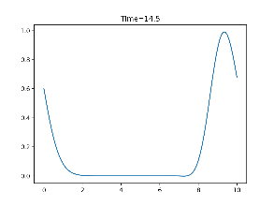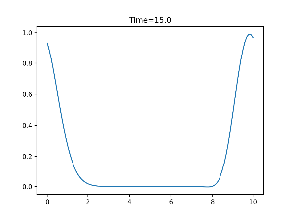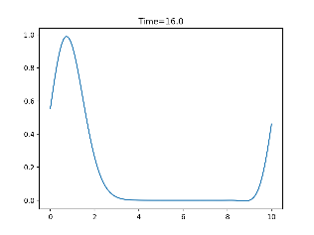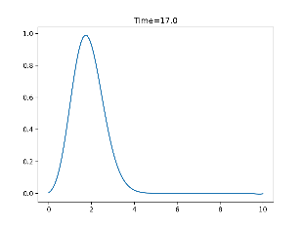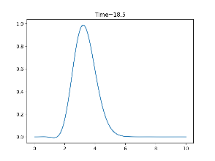

4- Lax-Wendroff scheme:

The results for Lax-Wendroff doesn’t differ much from the leapfrog (Figure 13), as we increase the resolution or the cf, the solution will be more stable as in Figure 14.

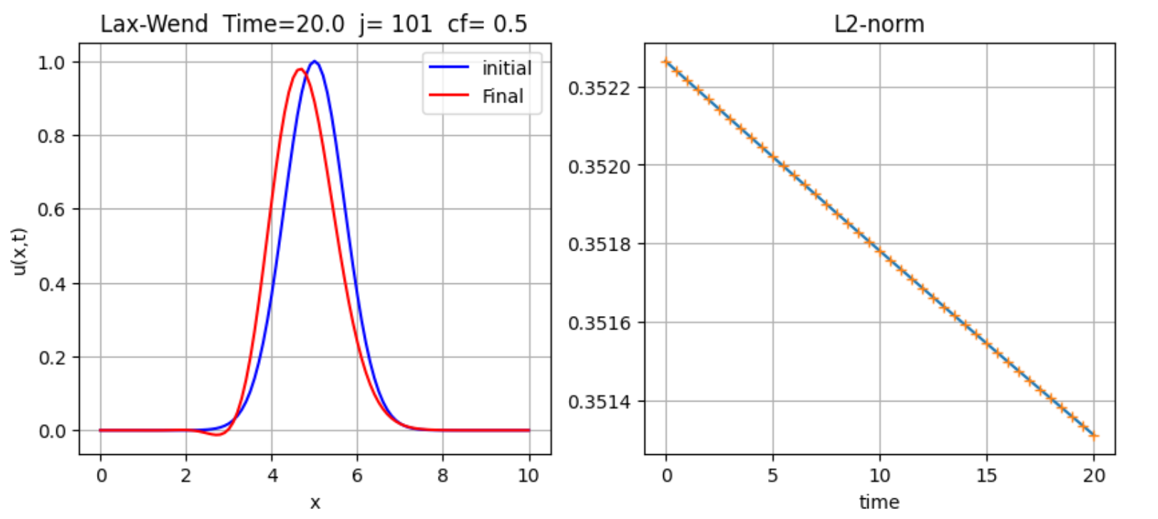

Figure : Lax-Wendroff initial data are not aligned with the final solution. The L2-norm is linear.

Some snapshots illustrating the function evolution through time for the final solution in Figure 13:

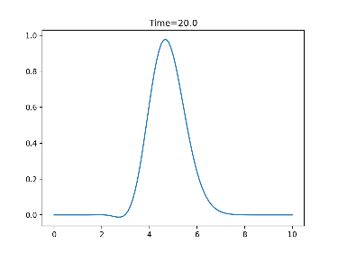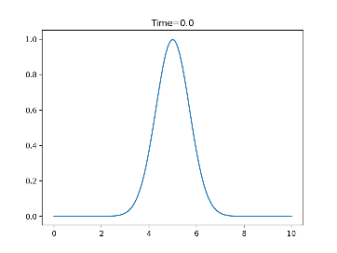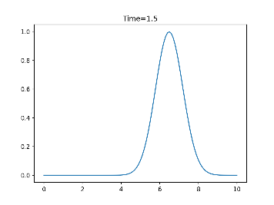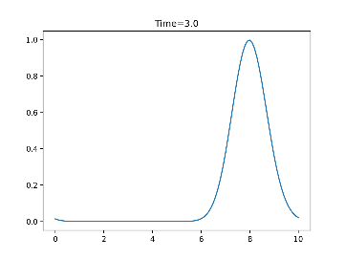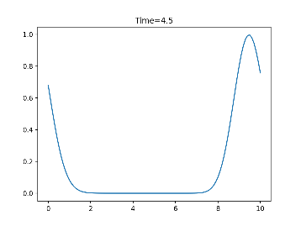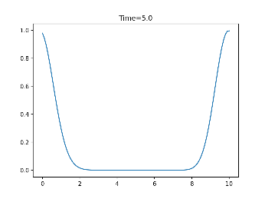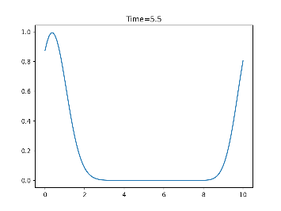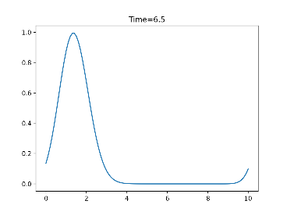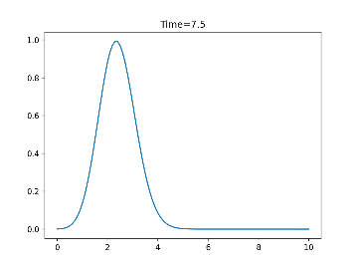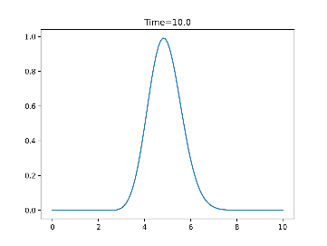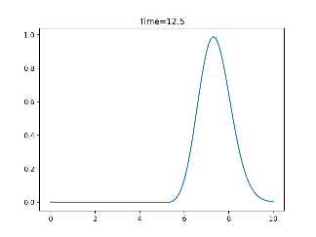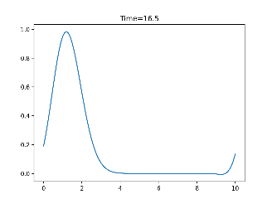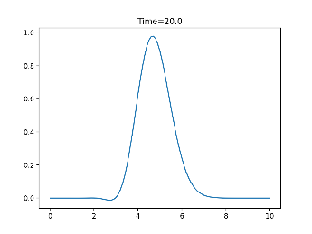

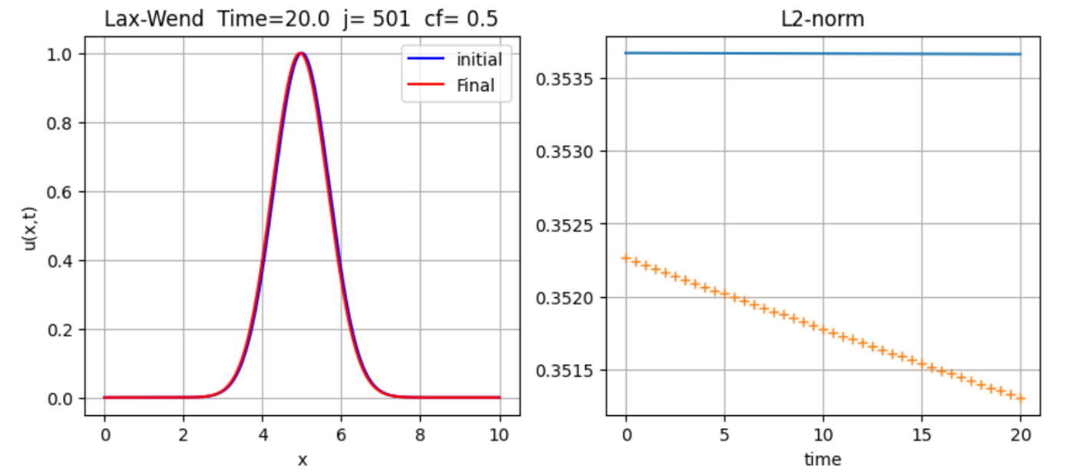

Figure : Maybe it is shaded, but the blue plot is behind the red one.